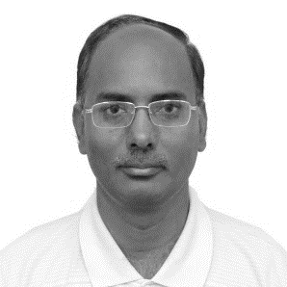**Prof S. N. Singh** obtained his M. Tech. and Ph. D. in Electrical Engineering from Indian Institute of Technology Kanpur, in 1989 and 1995. Presently, he is Vice-Chancellor, Madan Mohan Malviya University of Technology Gorakhpur and on leave from Professor (HAG), Department of Electrical Engineering, Indian Institute of Technology Kanpur, India. Before joining IIT Kanpur as Associate Professor, Dr Singh worked with UP State Electricity Board as Assistant Engineer from 1988 to 1996, with Roorkee University (now IIT Roorkee) as Assistant Professor from 1996 to 2000 and with Asian Institute of Technology, Bangkok, Thailand as Assistant Professor from 2001 to 2002. Dr Singh received several awards including Young Engineer Award 2000 of Indian National Academy of Engineering (INAE), Khosla Research Award of IIT Roorkee, and Young Engineer Award of CBIP New Delhi (India), 1996. Prof Singh is recipient of Humboldt Fellowship of Germany (2005, 2007) and Otto-monsted Fellowship of Denmark (2009-10).

Prof Singh became first Asian to receive 2013 IEEE Educational Activity Board Meritorious Achievement Award in Continuing Education. He is also recipient of INAE Outstanding Teacher Award 2016 and IEEE R10 region (Asia-Pacific) Outstanding Volunteer Award 2016. His research interests include power system restructuring, FACTS, power system optimization & control, security analysis, wind power, etc. Prof Singh has published more than 440 papers in International/ National journals/conferences and supervised 29 PhD (10 PhD under progress). He has also written two books one on Electric Power Generation, Transmission and Distribution and second is Basic Electrical Engineering, published by PHI, India. Prof Singh has completed two dozen of projects in India and abroad. Prof Singh was Chairman, IEEE UP Section for 2013 and 2014, and presently, he is IEEE Region 10 (Asia-Pacific) Conference and Technical Seminar Coordinator 2015-18. Prof Singh is also India Council Chairman-Elect 2017 of IEEE, the largest professional body in engineering.